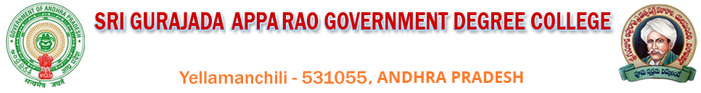
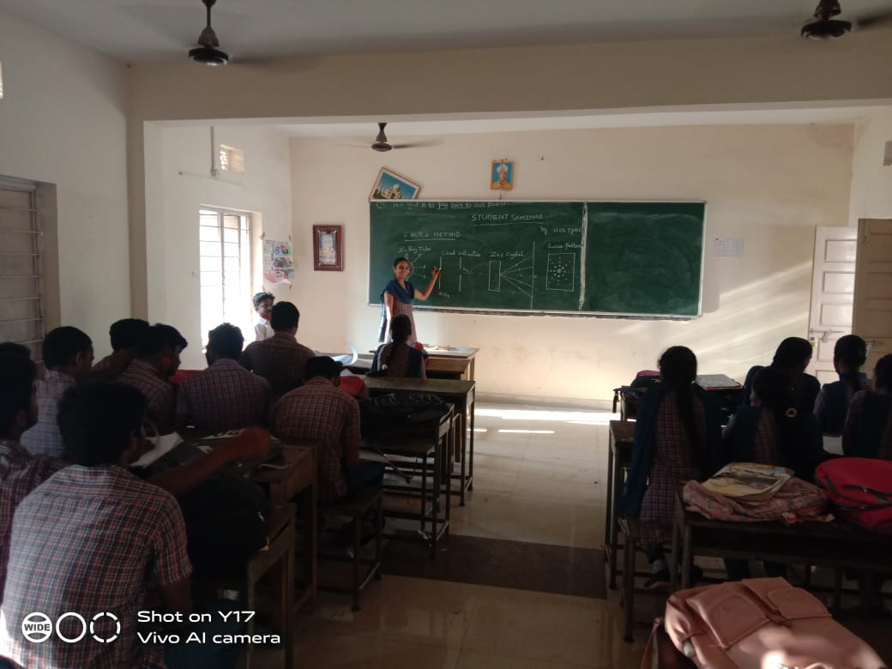
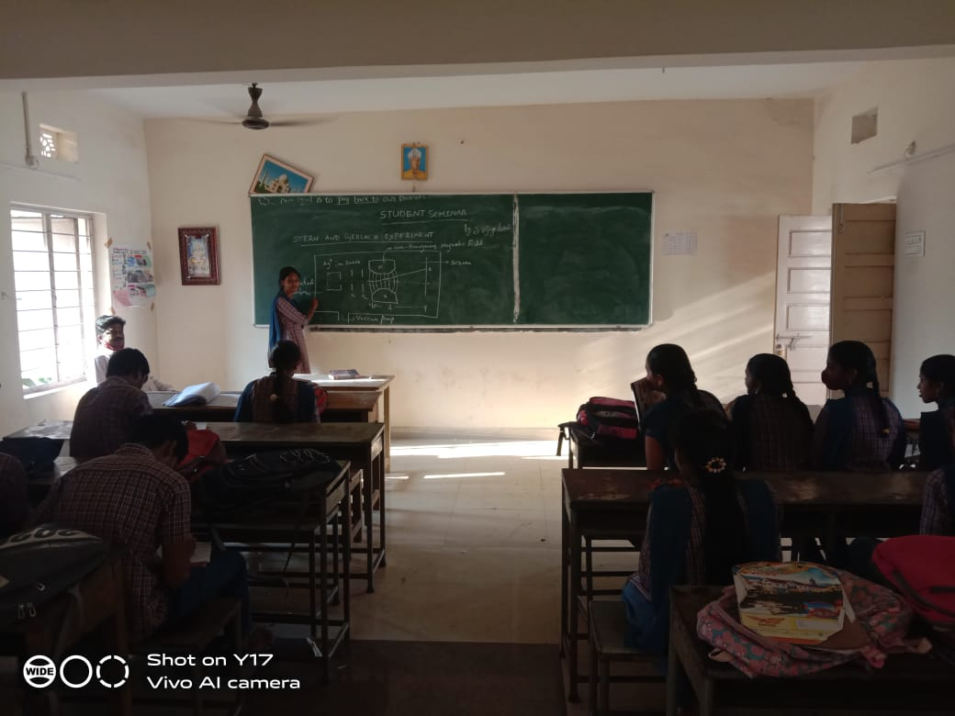
STUDENT SEMINAR BY CH JYOTHI ON”LAUE’S METHOD” AND S VIJAYA LAKSHMI ON “STERN AND GERLACH EXPERIMENT” DATED : 21-11-2021.

Signature of HOD Signature of the Principal

